**Batch: C2 Roll No.: 16010122267**

**Experiment / assignment / tutorial No. 10**

|  |
| --- |
| **TITLE:** Study of multiprocessor configuration concepts through Virtual lab |

**AIM:** Understanding Virtual Lab concepts

**_______________________________________________________________**

**Expected OUTCOME of Experiment:**

**__________________________________________________________________**

**Books/ Journals/ Websites referred:**

<http://vlabs.iitb.ac.in/vlab/labscse.html>

[http://vlabs.iitb.ac.in/vlab/#](http://vlabs.iitb.ac.in/vlab/)

<http://www.vlab.co.in/>

**_____________________________________________________________________**

**Pre Lab/ Prior Concepts:**

The main aim of this experiment is to provide remote-access to Labs in various disciplines of Science and Engineering. These Virtual Labs would cater to students at the undergraduate level, post graduate level as well as to research scholars. Also, to enthuse students to conduct experiments by arousing their curiosity. This would help them in learning basic and advanced concepts through remote experimentation. It also provides a complete Learning Management System around the Virtual Labs where the students can avail the various tools for learning, including additional web-resources, video-lectures, animated demonstrations and self-evaluation. We can share costly equipment and resources, which are otherwise available to limited number of users due to constraints on time and geographical distances

**Salient Features:**

. 1. Virtual Labs will provide to the students the result of an experiment by one of the following methods (or possibly a combination)

* Modeling the physical phenomenon by a set of equations and carrying out simulations to yield the result of the particular experiment. This can, at-the-best, provide an approximate version of the ‘real-world’ experiment.
* Providing measured data for virtual lab experiments corresponding to the data previously obtained by measurements on an actual system.
* Remotely triggering an experiment in an actual lab and providing the student the result of the experiment through the computer interface. This would entail carrying out the actual lab experiment remotely.

2. Virtual Labs will be made more effective and realistic by providing additional inputs to the students like accompanying audio and video streaming of an actual lab experiment and equipment.

**Observations**

**Title of Study Experiment: Karnaugh Map**

**Brief description of experiment under study:**

A Karnaugh Map, often referred to as a K-Map, is a valuable graphical tool used in digital logic design to simplify and evaluate Boolean algebra expressions. It presents a grid or table structure where binary variables are systematically organized in rows and columns. Each cell in the grid represents a unique combination of inputs for a given Boolean function.

The main objective of a Karnaugh Map is to facilitate the simplification of Boolean expressions. This simplification process is vital for optimizing digital logic circuits. It involves identifying and grouping adjacent cells with 1s (indicating 'true') or 0s (indicating 'false'). The objective is to find patterns and commonalities within the map that allow for the reduction of complex logic expressions. This simplification results in a more concise and efficient logical equation.

To evaluate a Karnaugh Map, follow these steps:

1. **Setup:** First, create the Karnaugh Map grid, ensuring that the number of rows and columns matches the binary variables in the Boolean expression. For instance, if you have two variables (A and B), create a 2x2 grid.
2. **Fill in the Grid:** Populate the cells of the K-Map with the corresponding output values (1 or 0) for each input combination based on the given Boolean expression.
3. **Grouping:** Identify groups of adjacent 1s (known as "minterms") in the map. These groups can be in the form of rectangles, squares, or other shapes within the grid. Make sure the groups cover as many 1s as possible while keeping the groups as large as possible.
4. **Simplify:** Each group represents a term in the simplified Boolean expression. Write down the corresponding terms for each group and combine them to form the final, simplified expression.
5. **Check for Don't Cares:** Sometimes, Karnaugh Maps include cells labeled as "don't cares" (X), indicating that the output value doesn't matter for certain input combinations. These cells can be used to further optimize the expression.

Karnaugh Maps are particularly useful when working with small to medium-sized Boolean functions, as they provide a visual and systematic approach to simplify and evaluate logical expressions. By minimizing the number of terms and variables, digital circuits can be designed more efficiently, leading to fewer components and reduced potential for errors in the design.

**Learning’s recorded:**

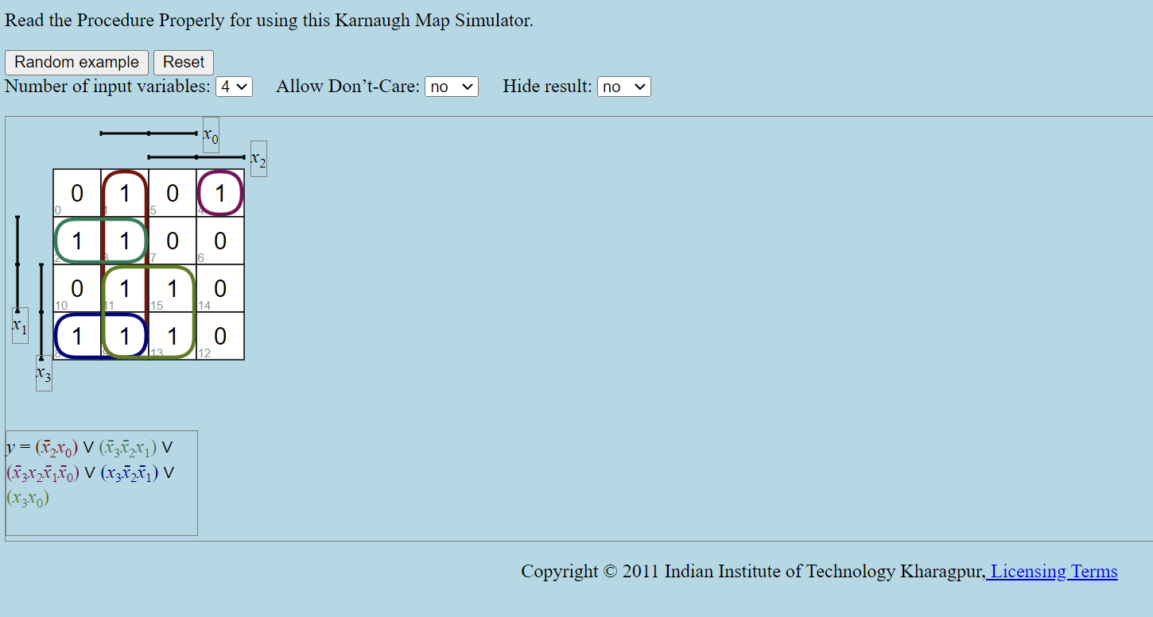

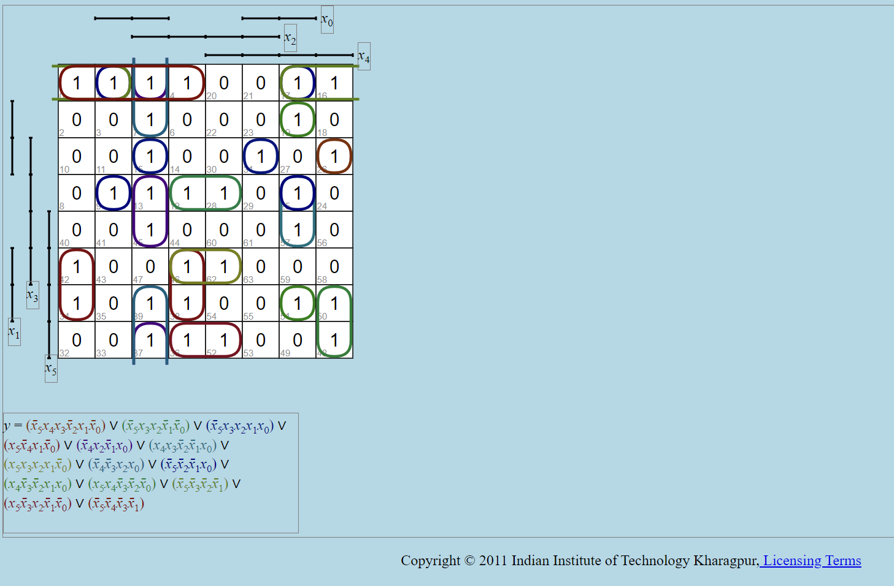

**Knowledge gained / Inference Obtained :**

Through the execution of this experiment, we not only learned how to evaluate a Karnaugh Map and streamline Boolean expressions, but we also drew several notable inferences. This practical exercise has illuminated the significance of K-Maps in simplifying digital logic circuits and has provided us with a deeper understanding of the power they hold in optimizing complex logic functions. By identifying patterns and logically grouping adjacent cells within the map, we unearthed a systematic approach to minimizing the number of terms and variables in our logical equations, which, in turn, fosters the development of more efficient and error-resistant digital circuits. This hands-on experience reaffirms the pivotal role Karnaugh Maps play in the realm of digital logic design, offering us a valuable tool to enhance the precision and efficiency of our future endeavors.

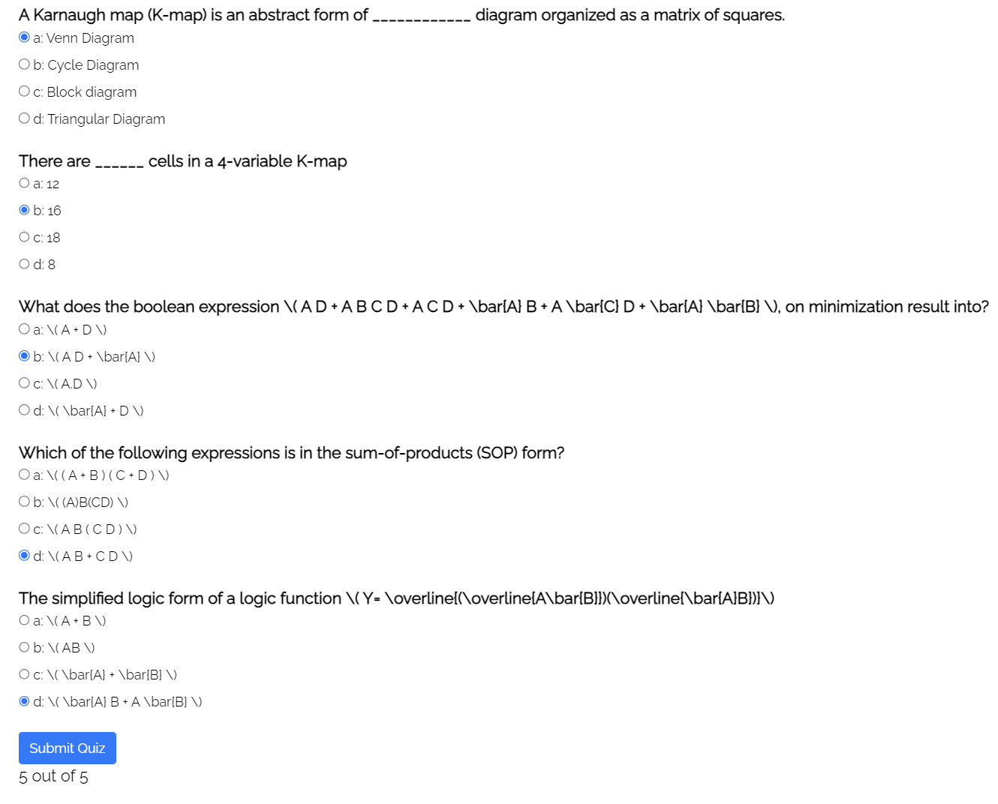

**Post Lab Descriptive Questions**

**1. What are the applications of the virtual lab case study / tool reviewed by you?**

Ans:

1. **Minimizing Complexity:** Karnaugh Maps and Boolean expression simplification techniques are instrumental in reducing the complexity of digital logic circuits. This is essential for creating more efficient and cost-effective designs.
2. **Error Detection and Correction:** These methods play a crucial role in detecting and correcting errors in digital circuits. By simplifying logic functions, engineers can identify and rectify issues in the design more effectively.
3. **Power Efficiency:** In today's world of energy-conscious design, Karnaugh Maps can be used to optimize digital circuits for power efficiency. By simplifying Boolean expressions, engineers can reduce power consumption in electronic devices.
4. **Space Optimization:** In applications where space is at a premium, such as in embedded systems, Karnaugh Maps are valuable for optimizing the use of limited space within a digital circuit.
5. **Real-time Systems:** In real-time systems like robotics and control systems, minimizing the complexity of digital logic is critical for ensuring that operations are carried out swiftly and accurately.

**Conclusion:**

In conclusion, a Virtual Lab offers an interactive and efficient way to learn Karnaugh Map concepts, making it easier to understand digital logic and circuit design fundamentals. This tool empowers students and professionals to practice Karnaugh Maps for simplifying Boolean expressions, optimizing circuits, and troubleshooting systems. It enhances education, aids in research, design validation, and competition preparation, and helps individuals bridge theory and practical application in the field of digital logic.

**Date: _____________**